### **Mulligan Simulation Document**

#### **Overview**

This Java program simulates the odds of needing a mulligan in a Pokémon Trading Card Game (TCG). A mulligan is needed if you don't have any Pokémon cards in your initial hand (7 cards).

#### **Key Components**

* **Card.java** – Represents a single card in the deck, which can be either "pokemon" or "energy".
* **Mulligan.java** – Runs the simulation and calculates the odds of needing a mulligan. It:
  + Shuffles the deck.
  + Deals a hand of 7 cards.
  + Checks if there is a Pokémon card in the hand.
  + Tracks how often a mulligan is needed and adjusts the deck over time.
* **MulliganTester.java** – Runs the simulation and displays the results.

#### **Simulation Process**

1. **Deck Creation:**
   * A deck of 60 cards is created: 1 Pokémon card and 59 energy cards.
2. **Shuffling and Dealing:**
   * The deck is shuffled randomly.
   * 7 cards are drawn to form the initial hand.
3. **Mulligan Check:**
   * If no Pokémon card is found in the hand, a mulligan is required, and the mulligan counter is incremented.
4. **Deck Update:**
   * After a set of trials, if there is less than the target number of Pokémon cards in the deck, one energy card is replaced with a Pokémon card.
   * The mulligan counter is reset, and the simulation continues with the updated deck.
5. **Odds Calculation:**
   * After completing the trials, the program calculates the odds of needing a mulligan based on the number of Pokémon cards in the deck and displays the result.

#### **Results**

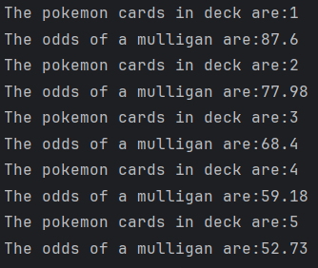

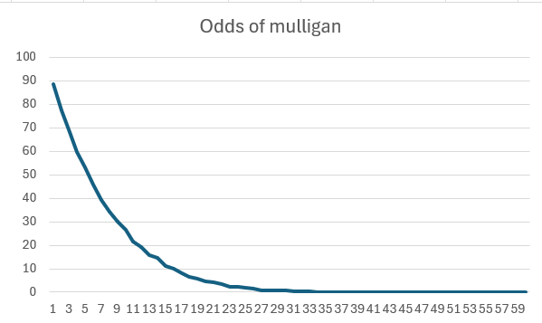

#### **Conclusion**

This simulation shows how the odds of needing a mulligan change as more Pokémon cards are added to the deck. Initially, the odds of a mulligan are high, but they decrease as the number of Pokémon cards increases.